Port Alfred Ratepayers and Residents Annual Report for the year 2017/2018
Our committee was reduced during 2017-18 due the fact that Tim and Ruth Cockbaine decided that they have had a long innings and planned to do some travelling. PARRA wishes them well and thanks them for all the hard work they did over the years.
We are fortunate in Ndlambe that our Municipality is solvent, pays its Eskom and water bills and keeps our pavements reasonably clean. The cleaning up after major events like the New Year’s Day Festivities is to be commended.
IDP and Budget
The Integrated Development Plan is meant to be done in 5 year cycles and should be the template on which the budget is planned. If an item is not in the IDP it cannot appear in the budget. Ndlambe’s IDP in is not linked to the budget and is at best a copy and paste from the previous year. The budget starts as a wish list of what the Directors want to spend. The NRF through Chris Bezuidenhout and myself have had numerous meetings with the budget steering committee in an attempt to reduce the rates increase to treasury guidelines, (inflation rate) which Ndlambe tend to ignore.
Examples of excessive budget items in the 2018/19 budget
Casuals: R 3.6 million
Overtime: R 6.4 million
An FNB loan of R 20 million (with no indication of how the loan is to be repaid).
Uniforms: R 1.8 million (which includes corporate branded clothing for senior officials)
Computers and IT: R 5.7 million
Catering: R 1.0 million
Employee costs exceed 40% of the total budget.

Roads
We are destined to have pot holes in most of our roads. Did you see in the news that Mumbai is the most potholed city in the world? (Most of our small towns have the same problem). The filling of potholes and then putting a slurry seal over the whole road appears to be more successful, but this is expensive. Brick block paving is being done on certain busy streets every year but is limited to the grant money received from the Province.
Bulk Water Supply
There is no forward planning of where Ndlambe is going to source its water from when the current dams and boreholes are not able to supply its growing population.
Sewerage
Their appears to be no commitment to rectify the frequent sewerage spills in van der Riet Street, Masonic Road, Mentone Road and Campbell Street. The sewerage works is a nightmare with little or no security and raw sewage often spills directly into the Kowie River. The Municipality does not even inform the residents when there is sewerage pouring into the Kowie River.
Valuation Roll
There are numerous problems with this roll where erven are valued at R 1.00 particularly in developments and the actual value is contained in the mother erf. PARRA is of the opinion that when an erf is registered the value must accrue to that erf and not be contained in the mother erf. The capture of the valuation data is not done consequentially. Residents could be Mr Adams or Adams Mr. Currently it is impossible to sort the Names or Companies in the Roll. There are numerous properties with no value and no owner on the Valuation Roll. ID numbers are missing and a huge effort is required to clean up this Roll.
Building and Departure Applications
Many of the applications the Municipality receives are flawed and PARRA have worked to have this remedied. One such example being the Cell Phone Tower application which was technically and legally flawed and was eventually rejected after constant intervention from PARRA. When applications are received neighbour participation and consultation is often lacking. The Ndlambe Planning Tribunal has recently been constituted but the ratepayers have no representation on this council.
Interaction with the Municipality
There is constant interaction between PARRA and the Municipality who are always willing to listen. However the wheels grind slowly and implementation is slow.
Stray Animals
There have been numerous court cases where Ndlambe Management has been found to be in contempt of Court but there does not appear to be any political will to solve the problem. PARRA feels the time has come for those officials who are in contempt of Court to pay the legal fees in their personal capacity and not lumber the ratepayers through their inability to abide by theses court decisions.
Small Boat Harbour
This is meant to be the jewel of Port Alfred. Unfortunately it is poorly maintained and new management needs to be appointed if we actually want to save the jetties which are dangerous, unstable and are in dire need of repair.
R72 and SANRAL
This appears to be a never ending saga. The poor traffic control by the contractors is very slap dash and has led to numerous accidents. The Municipality does not appear to have much input into the health and safety issues that are disregarded by the contractors on a daily basis.
I would like to thank all our committee members for the time in hard work they put into PARRA. I would also like to thank the Royal Marina for the use of their clubhouse.
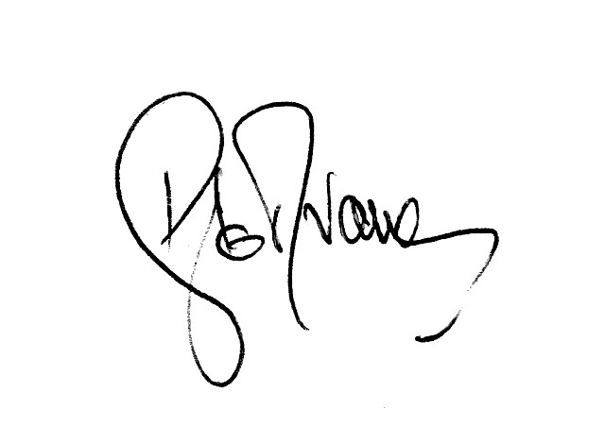
D le R van Wyk September 2018

