AGM MINUTES

Minutes of the Annual General Meeting of the Port Alfred Ratepayers’ and Residents’ Association, on Monday 21st October 2019 at the Royal Marina Clubhouse at 5.00 for 5.30 pm

1. Welcome: D van Wyk welcomed everyone and thanked them for their attendance.
2. Attendance: See Register
3. Apologies: R Ryan
4. Confirmation of Previous Minutes: Proposed: R Hicks, Seconded: D Quenet.
5. Matters arising from the minutes: None
6. Chairman’s Report: See Attached
7. Treasure’s Report: See Attached
8. Talk by S Babama Deputy Director of Infrastructure Ndlambe Municipality. The Deputy Director spoke about Port Alfred’s water problems. Amatola Water are a big problem as the plant they are building to ‘sweeten the water’ is not functional. The Municipality are trying with resolve the issues with Amatola Water but the problem is the Government insist the Municipality use Amatola Water. Director Vithi to have a comprehensive Water plan in place by early 2020 with plans and a budget to solve Port Alfred’s water problems.
9. Election of Office Bearers. The following people were nominated to stand for PARRA: D van Wyk, M Hosty, R Hicks, J van Wyk, D Quenet, D Hosty, C Crawford, C Oliver and R Oliver. S Venene seconded to PARRA.
10. General: S Boucher raised the issue of the Small Boat Harbour and its lease and who is responsible for the removal of the sand banks. He and R Schenk then got into a rather lengthy discussion about the issues. D van Wyk then asked both of them to continue this discussion after the meeting. As no other issues were raised the meeting was closed.
11. Closure: 18.30
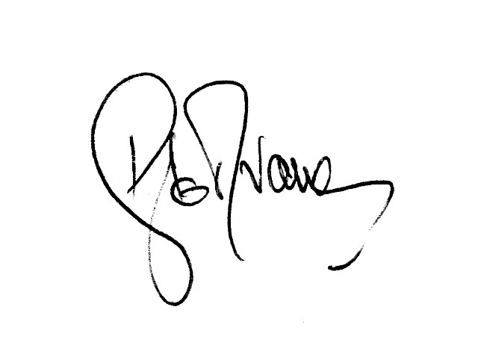

D le R van Wyk
Signed PARRA Chairman

