AGM MINUTES

Minutes of the Annual General Meeting of the Port Alfred Ratepayers’ and Residents’ Association, on Monday 17th September 2018 at the Royal Marina Clubhouse at 5.00 for 5.30 pm

1. Welcome: M Hosty welcomed all the residents who had made the effort to attend the AGM. He said that when he joined the PARRA Executive he soon realised that there was a lot of work done by the executive behind the scenes and he said the committee needed to be thanked for their work. M Hosty also stated that we live in a gem of a town which has a functional Municipality.
2. Attendance: See Register
3. Apologies: R Schenk, S Venene, C McKenzie, J & T van der Merwe,
4. Confirmation of Previous Minutes: Proposed: R Hicks, Seconded: S Pool.
5. Matters arising from the minutes: For Port Alfred to be on water borne sewerage a grant is needed which is pending.
6. Chairman’s Report: See Attached
7. Treasure’s Report: See Attached
8. Talk by E Mouton Geohydrologist: “Have the Ndlambe Municipality built resilience into the bulk water supply?” E Mouton outlined where Ndlambe’s obtains its water from. He discussed the Sarel Hawood Dam which has problems, the beach boreholes which have run dry, and the pipes which require maintenance. There are numerous problems associated with water which were discussed. There is not much planning taking place for future development and population growth.
9. Election of Office Bearers. The following people were nominated to stand for PARRA: D van Wyk, M Hosty, R Hicks, J van Wyk, D Quenet and R Oliver.
10. General: N Johannsen asked what PARRA had done about the Ndlambe valuation Roll where there were plots valued at R1.00. D van Wyk explained that the roll was actually closed and was going to be re valued early 2019, when these issues could be addressed. The NRF had met with the Valuator and had numerous meeting with Mr Klaas. PARRA are well aware that there are issues with some valuations but PARRA will not support the targeting of individuals. The rates are paid in the mother erf until the plots were surveyed and or sold. R Hicks then intervened and told N Johannsen that he took issue with her accusations and demanded an apology. This was duly given. She continued to labour the point.
11 Two Resolutions were put to the AGM.
- One that the PARRA subscription be a flat rate of R 50.00 per family.
- Two that the AGM and the Financial Year End be moved to later in the year when the weather was warmer. Both these Resolutions were unanimously adopted.
12. Closure: 18.45
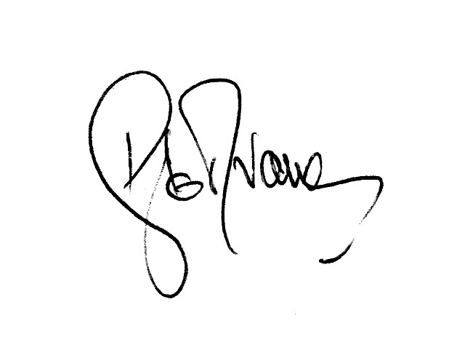

D le R van Wyk
Signed PARRA Chairman 17th September 2018

