Minutes of PARRA AGM held at Memorial Hall Port Alfred Thursday, 3rd August 2017

- Welcome: D van Wyk welcomed everyone present and thanked the Press for attending.
2. Attendance: See register
3. Apologies: P Kenard-Davis, Mr & Mrs McKenzie, R Alison, E & F Bradfield, J Wilson, J Ghee, P Allison & J Billing.
4. Speaker – His Worship the Mayor Phindile Faxi: The Mayor said that because of the economic situation in the country we must all come together to help each other. Port Alfred needs to promote tourism to provide employment. The service delivery protests are about housing. The Mayor had written to the Minister of Human Settlements to assist. Badly built houses need to be fixed and new houses built. The biggest problem in Ndlambe is Bulk Water Supply. The Ndlambe area cannot develop without water. The Premier of the Eastern Cape came to Port Alfred to meet with the Mayor to try to address these two critical issues. 780 new houses will be built and the criteria for receiving a house will change. The destitute, the aged and child headed households will be the first to receive houses. The Mayor also said the Municipality was trying to resolve the Small Boat Harbour issue. The issue of stray animals causing accidents needed to be addressed.
5. Confirmation of Minutes: AGM 15 August 2016. Proposed R Hicks. Seconded T Cockbain.
6. Matters arising: None
7. Chairman’s Report: See attachment
8. Treasurer’s Report and Financial Statement: See attachment
9. Nomination and Election of Members of the Executive Committee: The following Members were nominated, D van Wyk, J van Wyk, T van der Walt, R Hicks, S Poole, D Quenet and M Hosty.
10. General Discussion: Ratepayers raised the issue of the flawed housing lists which created problems for residents waiting for houses. The issue was also raised that families receiving houses then rented them out to receive an income. It is apparent that the system of allocating housing is deeply problematic & the cause of tension among residents.
11. Ward 10 Municipal Communication: G Galbraith on behalf of the Ward 10 War Room said that the new Municipal communication policy was not discussed with anyone and the War Room believe the policy is flawed.
12. Closure: Meeting closed at 6.35

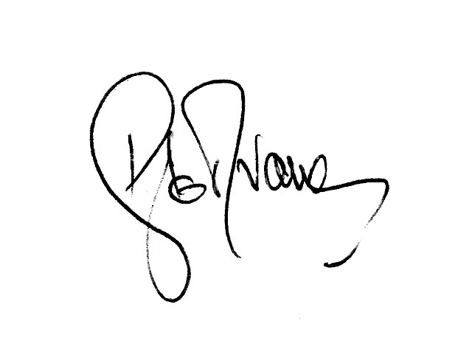
Signed______________

