PARRA Chairman’s Report 2019
Good evening ladies and gentleman I have the pleasure of submitting the Chairman’s’ Report for this period. I would like to thank our Exco for all the hard work done during this period. We welcomed three new members to Exco, Scarra Venene, Ray Oliver and Boyce Xamesi.
Exco has been quite busy during this period and although we only have 7 members we have managed to get quite a few things done.
- Budget and IDP
Numerous meetings with NRF and the Municipality in an attempt to do away with the Directors “wish lists” has resulted in a budget that balanced and an acceptable increase to the Ndlambe ratepayers.

Item | Increase | Comment
Property Rates | 5.2% = .0111 cents per Rand | Effective 7.2% with 2% adjustment for rebate
Residents
Water | 6.00% | Reduced from Amatola’s higher tariff
Electricity | 13.07% | Fixed by Nersa and Eskom
Sewerage | 6.00%
Salaries | 6.50%
Ndalmbe
Electricity | 15.63% | Nersa and Eskom’s increase
Water | 10% | Amatola’s increase
Maintenance | Increased by 61% over 2018-19
External Funding | R15m -36 months | 12% interest

PARRA wrote a letter to the CFO and Municipal Manager about the massive debt write offs. No response was received.
PARRA wrote a letter to the CFO and Municipal Manager about the large amount of rate payers money budgeted (R 450,000) to be spent on a “Music Festival”. Ratepayer’s money should be spent on improving services which are badly needed like improving the roads, water and sewerage. No response was received.
PARRA has asked Ndlambe to make sure all indigents are registered so that the Municipality can get the maximum income from the “equitable share” from the government that they are entitled to.

- 2019 Valuation Roll
Numerous meetings were held with Valuators and the Municipality. Anomalies and incorrect calculations were pointed out and fixed by the Valuators. The Roll is still not a 100% but is a vast improvement on the previous Roll. PARRA have a copy of the Roll and if anyone wants to look at it and compare values I have an excel version that can be sorted. Unfortunately the data that has been captured is not done in a standard way and some entries start with Mr. some with a Surname and others with the initials. The Municipality needs to clean this up as it originates from the Ndlambe Accounts data base.

- Water
Ndlambe and specifically Port Alfred is a water SCARCE area. Although strict water restrictions are in place numerous residents either ignore them or are not aware of them. The Sarel Hayward Dam has no catchment area and is basically a reservoir that is normally fed from the weir at waters meeting. There is however no water flowing down the Kowie river into the weir and thus the dam is not being replenished. The east beach dunes water source has been revived and the only other sources of water are the boreholes in the central belt that are being over utilised. The capacity of the water treatment plant is not sufficient especially during the holiday season to supply Port Alfred with potable water. There are often problems in the balancing dam with algae and blocking of outlet to the water treatment plant. Numerous think tanks have been held to solve these problems and hopefully the situation will improve early next year.

- Sewerage
Most of Nemato is now on water borne sewerage but over 60% of the West Bank is not. The effluent from all these residences not on water borne sewerage is poisoning the ground water! Every year a grant is applied for to put the whole of Port Alfred on water borne sewerage but the funds are never forthcoming from government!
Port Alfred also has certain areas prone to sewerage leaks (Wharf Street Biscay Road and van der Riet Street) on a continuous basis and this never seems to be resolved by the Municipality.

- Ferryman’s Hotel
The owner Mr Klein agreed at meeting with the Municipality, Ward 10 Councillor, Ndlambe legal representative and the PARRA chairman promised to fix the front facades of the Annex and the Main Hotel. The Annex would be painted, burglar barred and broken windows by the middle of October. The Main Hotel’s facade would be painted and fixed by the middle of December

- Town Planning, rezoning and departure applications
The Ndlambe Planning Tribunal is now up and running. Applicants now have to prove that they have sent letters to all neighbours.
This is a problem as there is no other protocol in place to ensure neighbours are informed of proposed re-zoning or departure applications.
Notices are published in the press but only have Erf numbers not addresses.
PARRA has repeatedly asked for street names and house numbers to be included in the notices.

- General
PARRA has written numerous letters to the Municipal Manager during the year. Unfortunately not all received replies. Letters were mostly about stray cattle, the state of the small boat harbour, water leaks, sewage leaks, state of the sewerage works, East Beach ablutions, untidy overgrown pavements and storm water drains not being cleared. PARRA also wrote objection letters to the erection of Cellphone Mast within residential areas. PARRA also participated in Interested and Affected Party meetings to the applications for sand mining near the 43rd Air school. Generally the requests to clear overgrown pavements and clearing blocked storm water drains are met with a positive response and the drains and pavements are cleared.

- East Beach Ablutions
These remain an area of concern as they are being continuously vandalised. Mike Hosty from PARRA, Richard Heaney from the Board Riders together with the Municipality will meet to see if any solution can found.

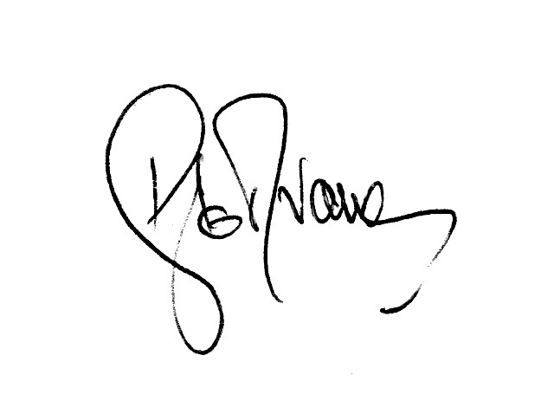
Dawie van Wyk 21st October 2019

